**LOS PERALES LIBRARY**

**VOLUNTEER INSTRUCTION PACKET**



**WELCOME!** Thank you for being a part of our volunteer team! The work you do is very important; without you, the library could not function as it does! Here is an overview of our library, some guidelines and general instructions to follow. Please feel free to ask questions at any time.

Please Sign In, in the “Volunteer binder” on the counter in the office when volunteering at the school. Volunteer badges must be worn at all times while on campus. Remember to return your badge when finished.

Please arrive a few minutes before your scheduled time to get updates and find out what is going on during the class period for the day.

If you cannot make a scheduled time please find a substitute if possible. If you are not able to attend, regardless of whether you’ve found a sub, please notify the librarian via email, [crussell@moraga.k12.ca.us](mailto:crussell@moraga.k12.ca.us).

Please make alternate arrangements for non-school aged siblings.

Library volunteers should refrain from using their cell phones during their time in the library please.

**WHAT HAPPENS IN OUR LIBRARY**

Students visit with their class once a week for 30 minutes if in TK-3 or 45 minutes if in 4-5. As they enter they sit on the carpet for a read aloud experience and discussion of library skills. There may also be some table work during the class. There is time at the end for book selection and check out. During a shift, the volunteer checks in or renews materials, shelves returned items and assists with any table work. Then when it is time to check out, the volunteer manages the circulation desk and checks out the student’s books.

**WHERE BOOKS ARE SHELVED IN THE LIBRARY:**

The Library is divided into six main sections. If you look at the spine of the book the label will have one of these.

* + Non-Fiction (Dewey Numbers)
  + Biography (B)
  + Picture Books – Early Readers (E)
  + Fiction (F)
  + Reference (REF)
  + Story Collection (SC)

Theses sections are broken down further to help the early readers and those transitioning to chapter books. Within the above sections if a book has this sticker on it, then it means it is for typically K-2 readers. (nonfiction, biography, fiction – all have transitional sections)

**

**Non-Fiction** – are shelved strictly numerically and alphabetically according to the Dewey Decimal System, **by complete number and then by last name of the author.** P*lease make sure to check to next shelve to make sure the call numbers do not continue on the following shelve.* These books start at the computers against the wall and go around the back wall until the Biography section. There is also a section of early reader/transitional non-fiction books on the shelves at the circulation desk.

**Biographies** are filed alphabetically by the last name of the person to whom it concerns. These books are the first column in front of the non-fiction wall. On the wall at the end of the sections are the transitional ones for the younger readers and will have the blue transitional sicker.

**Early** – These are picture books, shelved alphabetically by the first 3 letters of the author’s last name. These books are located in the two columns between Biography and Fiction.

**Fiction** – strictly shelved alphabetically by the author’s whole last name. ie: Banister comes before Bannister. *Please make sure to check to next shelve to make sure the call letters do not continue on the following shelves.* These books are located on the two columns closest to the new books/seasonal wall. There are also some Fiction chapter books under the circulation desk shelves closest to the computer section. The complete set of Nancy Drew Mystery Stories, The Hardy Boys, and The Adventures of the Bailey School Kids are located on the shelves in front of the computers. These are chapter book series for the reader who has moved past the transitional fiction series level. These have an orange dot.



**Graphic Novels** There is a section of fiction books (F) that are considered graphic novels. They have this sticker on the spine. They have their own section at the end of the Fiction section and before the Story Collection.



**Reference** - are shelved strictly numerically and alphabetically according to the Dewey Decimal System. These books are located at the end of the nonfiction section on the shelves on the opposite side of the Biography section.

**Story Collection** – filed strictly by the author’s entire last name. They are shelved on the back corner of the side wall closest to the new books section.

**Oversized Books –** There are three small sections on the side wall where the books that are oversized go. There are two sections of picture books (E) and one section of Story Collection (SC). This books all have a yellow dot on the spine.



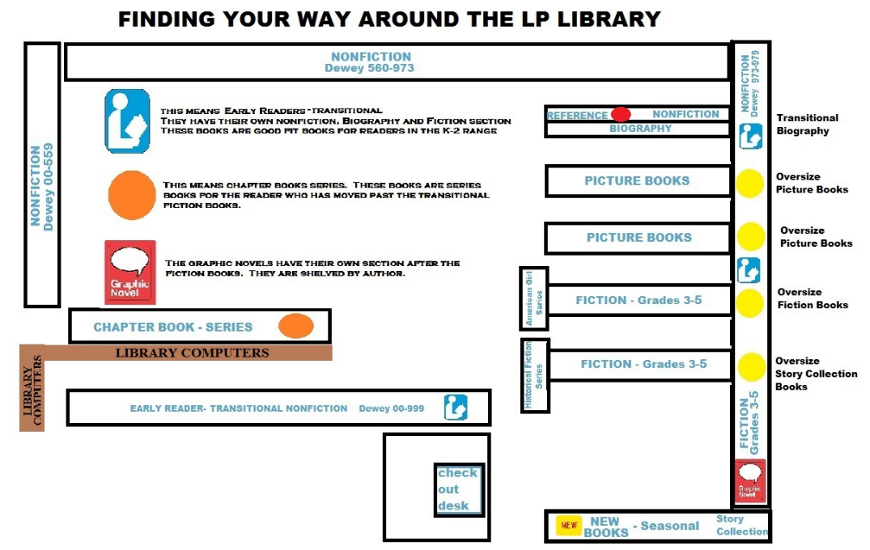

**LIBRARY RULES**

**L**isten during story time and keep your hands to yourself. Please remember no talking when adults or other students are speaking.

**I**nside voices in the library.

**B**e sure to push your chair in before you leave and use a shelf place marker when looking for books.

**R**espect the books, classmates, your librarian, parent volunteers and the computers.

**A**lways eat and drink outside the library.

**R**ead good fit book and don’t be afraid to try different genres!

**Y**ou must turn in the library pass to an adult if you need to use the restroom. Only one student at a time.

**WAYS VOLUNTEERS CAN HELP DURING THEIR SHIFT**

* Check books in and shelve them as they are returned.
* Check books out to the students.
* Keep the shelves in good order.
* Help keep order on the checkout line, at the computers, at the shelves, etc.
* Help with special projects as they come up.
* Respect student privacy and confidentiality.

**BENEFITS TO VOLUNTEERS**

* The ability to see their student in action.
* They get to listen in on stories being read as they work.
* They are among the first to view new book shipments.
* They enjoy borrowing privileges.

**BE COMMITTED AND DEPENDABLE**

* Make sure you have the time to serve.
* Be prompt and reliable; people are counting on you to be there.
* Arrange for a substitute if you are unable to make your shift.
* Make sure to help all students as needed. It is tempting to work closely with your own child but this volunteer opportunity is one working with the whole class.

**STEPS TO CHECK IN BOOKS**

* From the Circulation Desk main screen, (Green “Circulation” tab at top)
* Click the mouse on the “check in” button.
* Scan the barcode for each book. *Check the screen after each scan to make sure the transaction is recorded*. If the scanner does not respond to a particular barcode, please type the book’s barcode number on the keypad and hit enter. *Check the screen to be sure the correct book was checked in.* Sometimes a special message will appear. Please watch for this!
* “This book was lost” may appear. If so, please write those words on a post-it note, affix it to the book, and place the book on the back counter. We may need to issue a refund, and the librarian will deal with this at a later time. Again, *the message needs to be cleared by hitting the OK button first before proceeding to additional check-outs.*

Please briefly inspect the condition of each book that you check in. If a book returned is in need of repair, please check it in first, then put it in the book hospital with a post-it indicating such.

**STEPS TO CHECK OUT BOOKS BY HOMEROOM**

* From the Circulation Desk main screen, (Green “Circulation” tab at top)
* Click the mouse on the “check out” button.
* Now you will have the option to check out by patron or homeroom
* Click on homeroom and pull the correct class up from the drop down menu
* Once the class is on the screen click on the person who will be checking out
* Once the student’s name appears on the screen, check to make sure they are eligible to borrow books (the student does not have any overdue books, nor are they already at their check-out book limit).
* Next, scan the book’s library barcode, checking the screen EACH TIME to make sure the transaction appears.
* Once you have checked out all their books double check that the number on the screen matches the number of books. Sometimes it can sound like it was checked out but the title does not appear on the screen.
* Finally, stamp the back of the books with the appropriate stamp based on their check-out time allowance.
* ie: 1 week for 1st graders. Note: If the “Date Due” sticker on the back of the book is full, if possible, first remove the old sticker(s), then place a new sticker in its place. Stickers are kept in the drawer next to the computer.

**TO CHECK OUT BOOKS BY PATRON NAME:**

* Green “Circulation” tab at top
* Click on “Check out” on left tab
* Click on “To Patron” tab at right
* Type last name at “Find”
* Click “Go” button or enter on keyboard
* Click on name
* Scan book bar code
* Stamp due date

**TO RENEW A BOOK:**

* Green “Circulation” tab at top
* Click on “Renew” on left tab
* Scan the book and the book will show renewed to that student on the screen

**TO PUT A BOOK ON HOLD THAT IS CHECKED OUT AT THE LIBRARY:**

If student requests that we put a book on hold or reserve, please have him/her fill out a hold form. On one of the book wish papers. The request should include:

* Name, Date, Class, Book Title

Once the form is filled out put it in the mail slot for the librarian to input later.

**WHAT TO DO WHEN A BOOK RETURNED HAS A HOLD ON IT:**

When a book on hold is returned, the computer will alert you with a message as you check the book in. Please write the child’s name that is indicated in the computer message on a note, put that note in the book and place the book on the hold rack. Click OK and you can continue checking books in. The librarian will then send a note to the student that their requested book has been checked back in.

**BEHAVIOR IN THE LIBRARY**

Students are encouraged to be respectful of each other and of library materials at all times. Rules of quiet order are enforced; those that are not cooperating will be benched at recess.

Volunteers help to keep order on the checkout line, at the computers, and at the tables while we help individual students find books and monitor behavior at the shelves.

At all times, students are required to remain on the ***outside*** of the library circulation workspace. Unfortunately, we may NOT allow them to use the librarian’s computer or the barcode scanner.

**RULES FOR BORROWING:**

Transitional Kindergartners may borrow one book for one week.

Kindergartners may borrow one book for one week.

First graders may borrow two books for one week.

Second graders may borrow two books for one week.

Third graders may borrow up to three books for one week.

Fourth graders may borrow up to four books for two weeks.

Fifth graders may borrow up to five books for two weeks.

**OVERDUE BOOKS**

There are no fines for overdue books; however, students must return overdue items before new items may be checked out. Students who have overdue books are able to read books in the library, but are unable to take them home. If a book is lost or damaged it is the responsibility of the student to replace the book.

**OVERDUE BOOKS AND PUTTING BOOKS ON HOLD**

If a student forgets their books they cannot put a book on hold that is in the library. It is a good reminder to bring their books back on the day they are due. They can read books during their library class, recess and lunch period.

