LIBRARY INFORMATION AND GUIDELINES
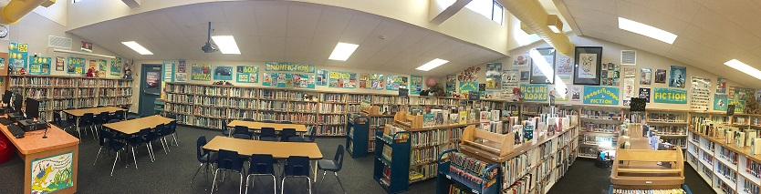

Your child will be visiting the school library once a week for 30 minutes if they are in grades TK-3 and 45 minutes if they are in grades 4-5. During this time, the students will hear stories, learn about authors, practice information and research skills suited to their grade level, celebrate literary events and borrow books. They will enjoy sharing their books with you, and will greatly benefit from the time you spend reading them together. You will enjoy and benefit also!

BOOK BORROWING:
Transitional Kindergartners may borrow one book for one week.
Kindergartners may borrow one book for one week.
First graders may borrow two books for one week.
Second graders may borrow two books for one week.
Third graders may borrow up to three books for one week.
Fourth graders may borrow up to four books for two weeks.
Fifth graders may borrow up to five books for two weeks.

Please be aware of your child’s library day! Encourage them to pack their books in their backpacks the night before they are due. If your child has not finished their book within the borrowing timeframe they can always renew their book on their library day.

It is a good idea to have a special place at home where library books are kept. This place should be visible, and safe from pets, babies, toddlers, and sticky or wet substances.

There are no fines for overdue books; however, students must return overdue items before new items may be checked out. Students who have overdue books are able to read books in the library, but are unable to take them home. If a book is lost or damaged it is the responsibility of the student to replace the book.

Please feel free to contact me with any questions or concerns.
Constance Russell, LP Librarian
crussell@moraga.k12.ca.us

